PostgreSQL server Advanced 6

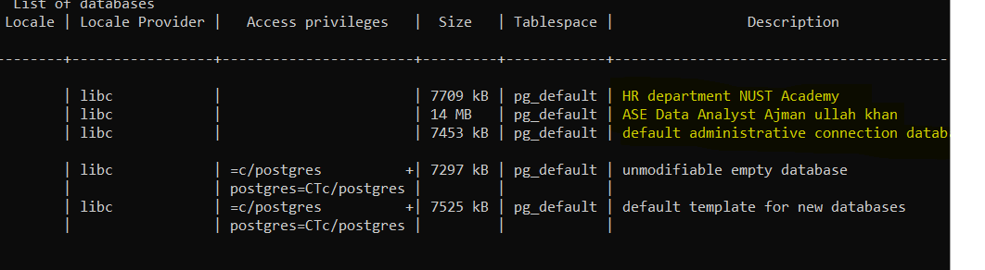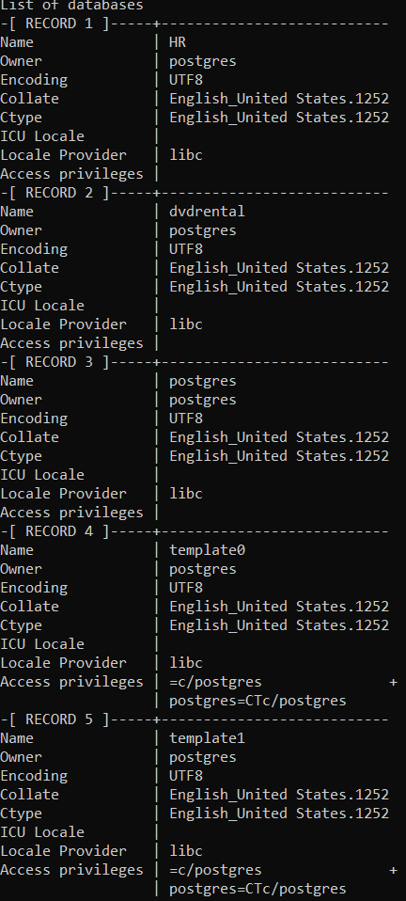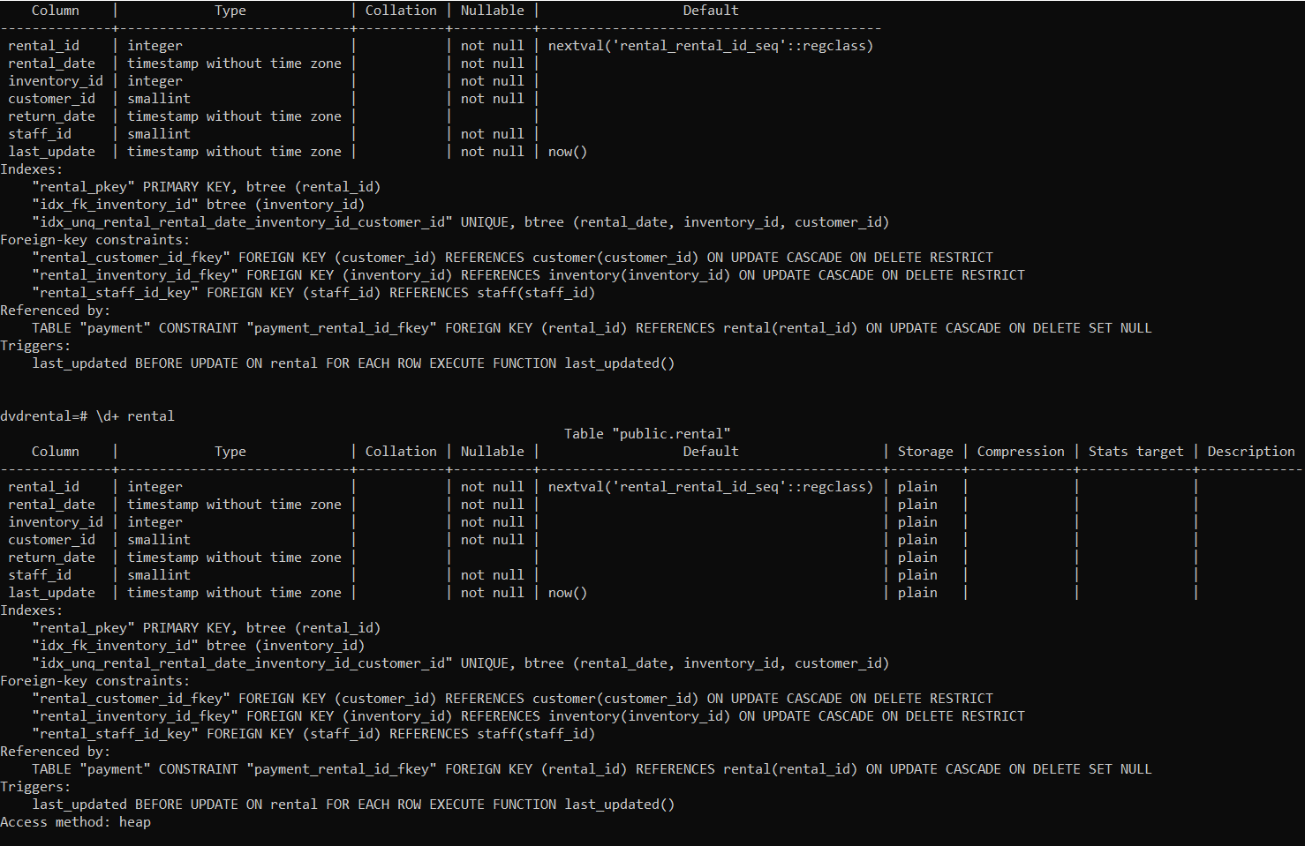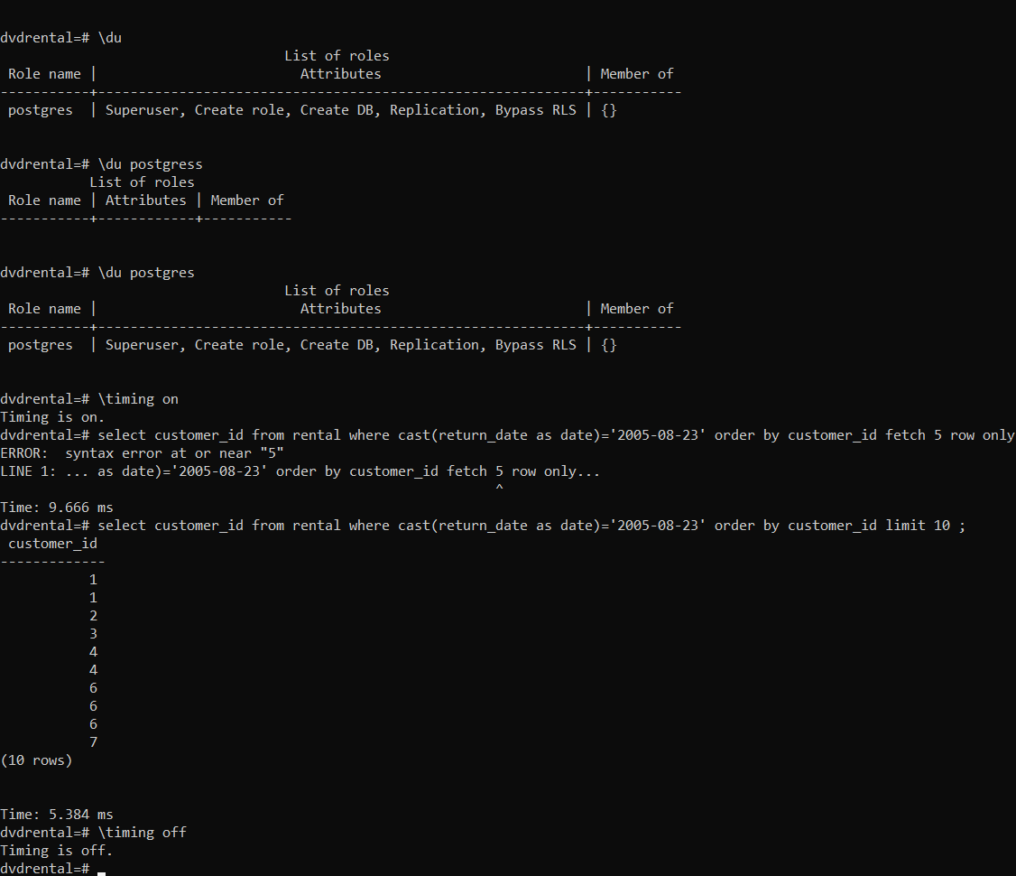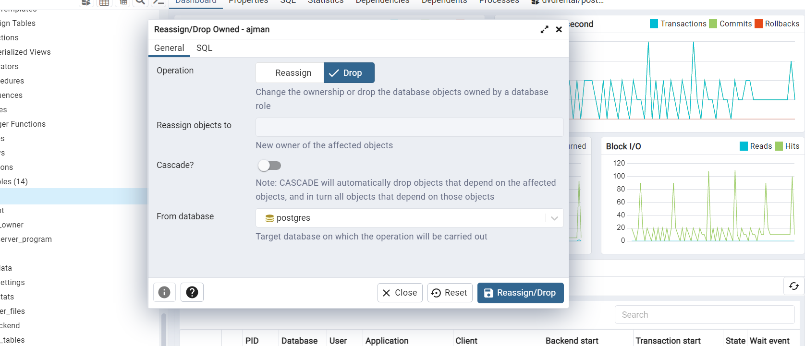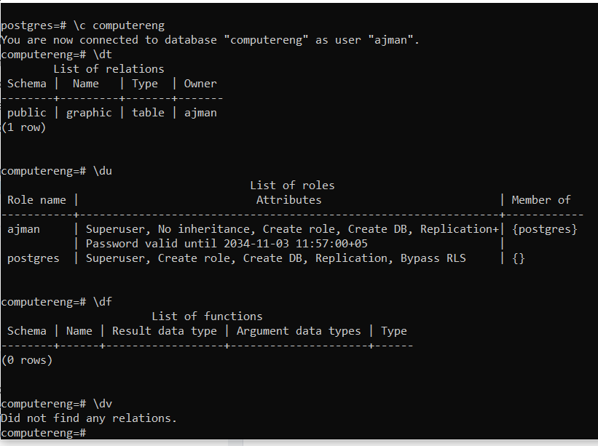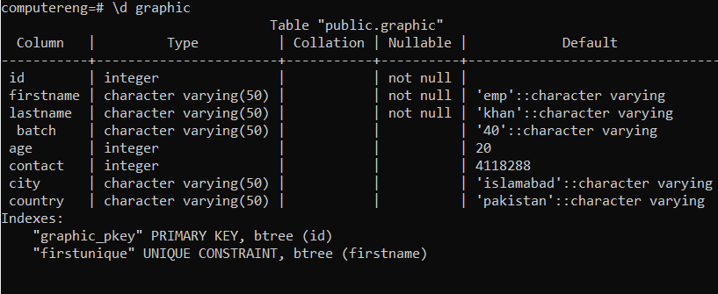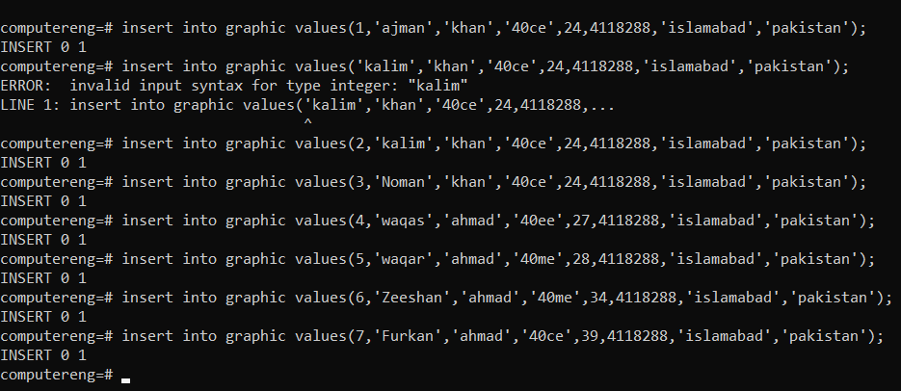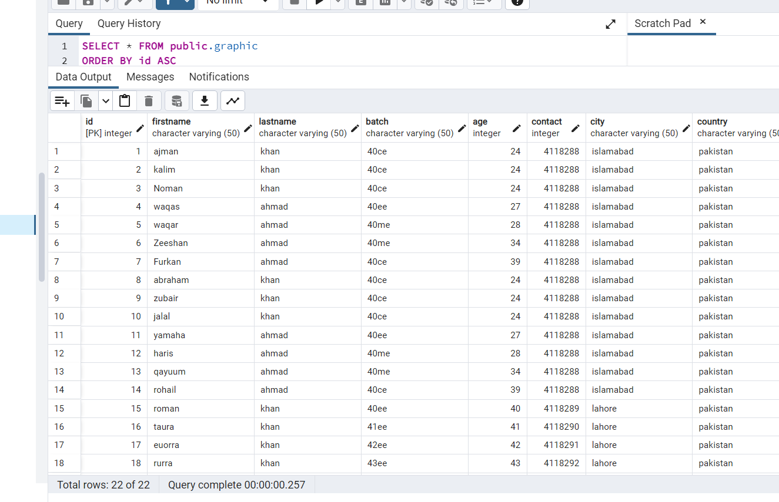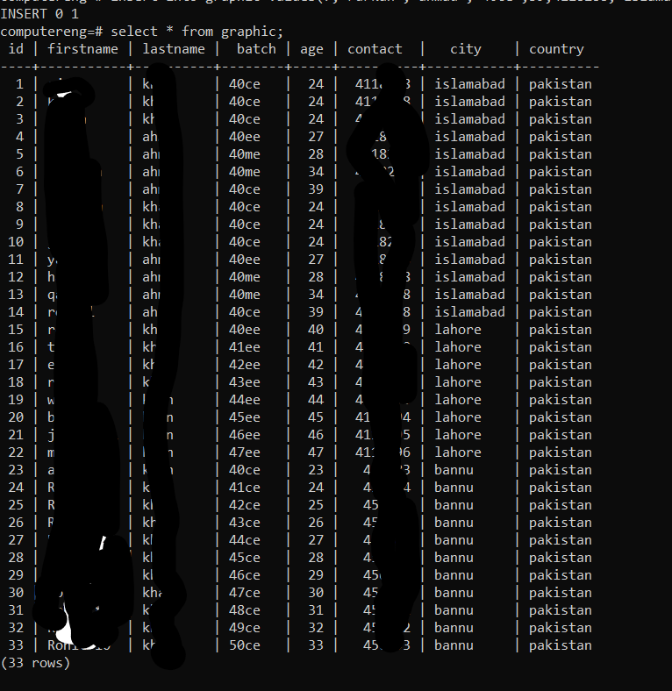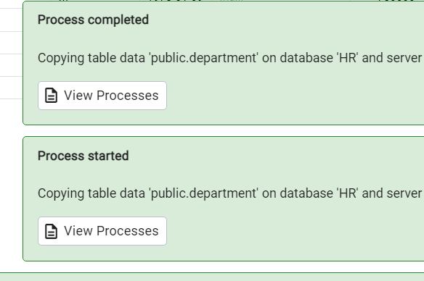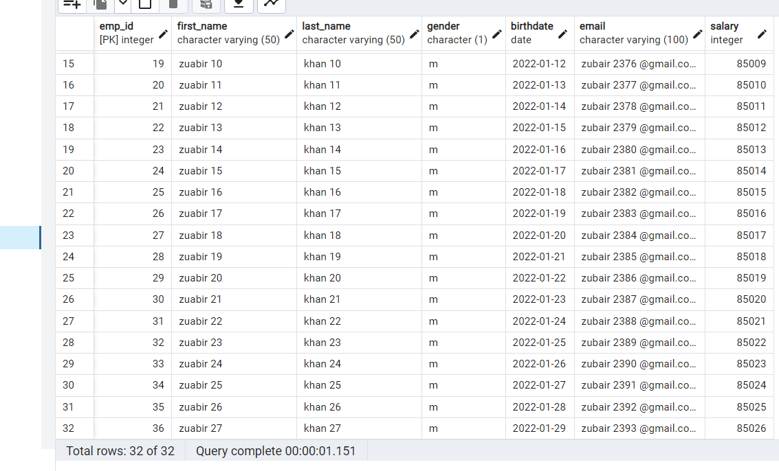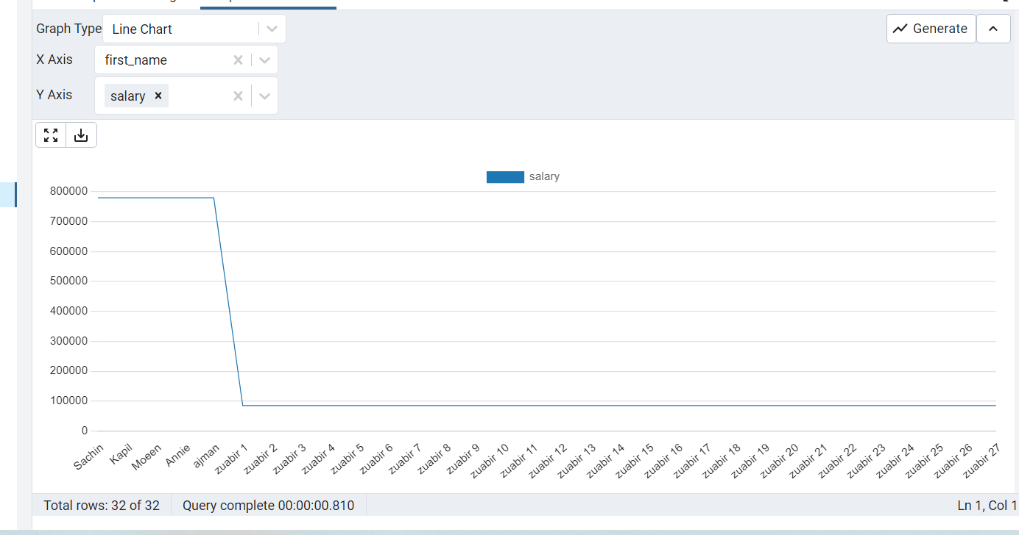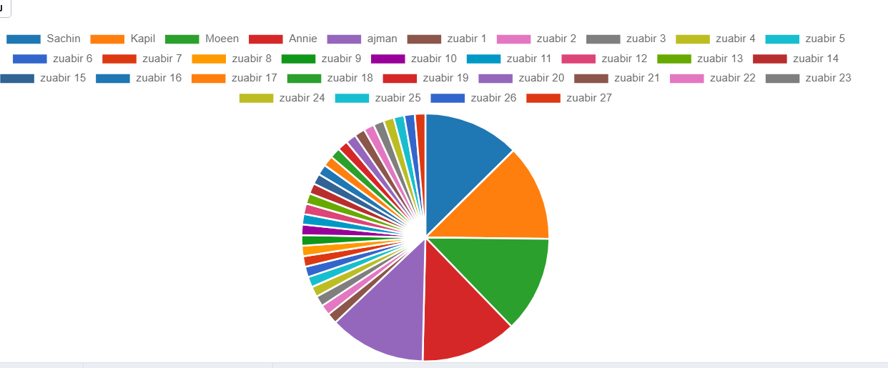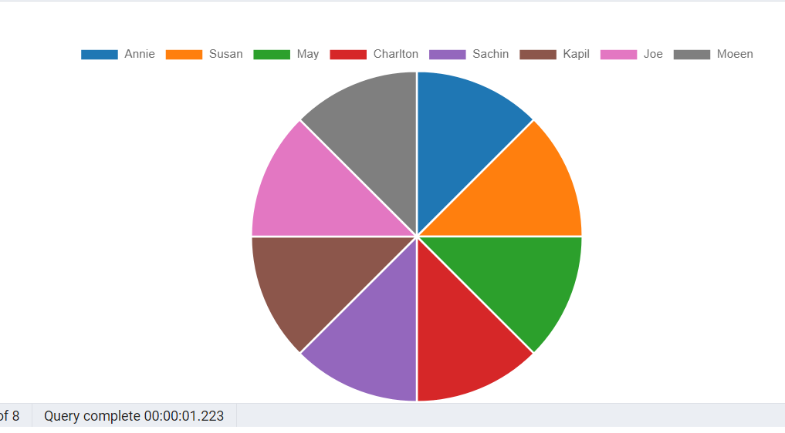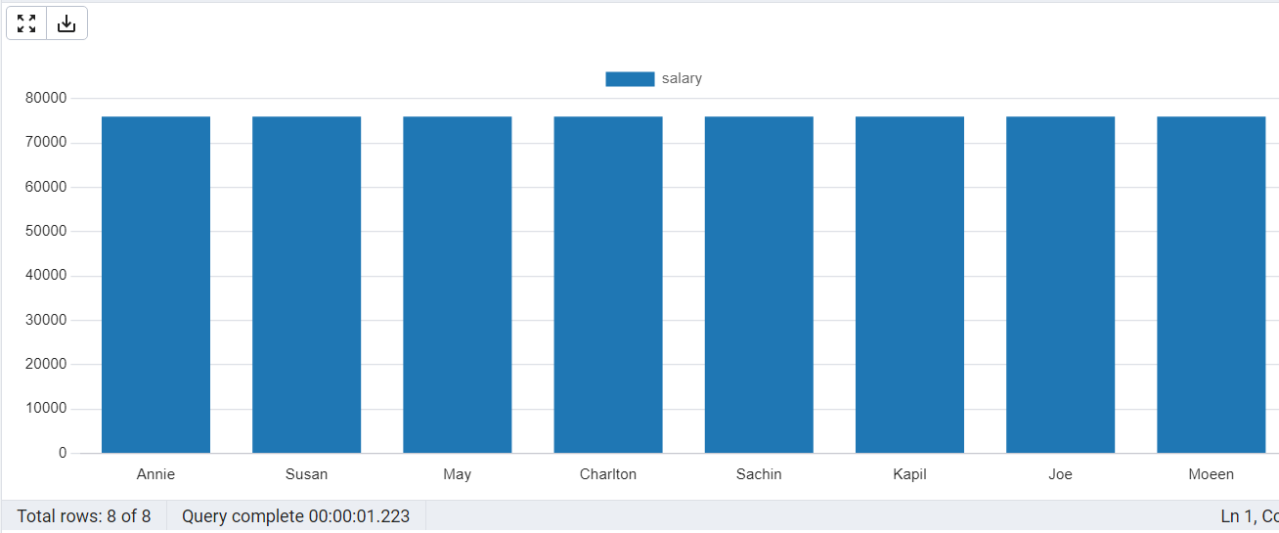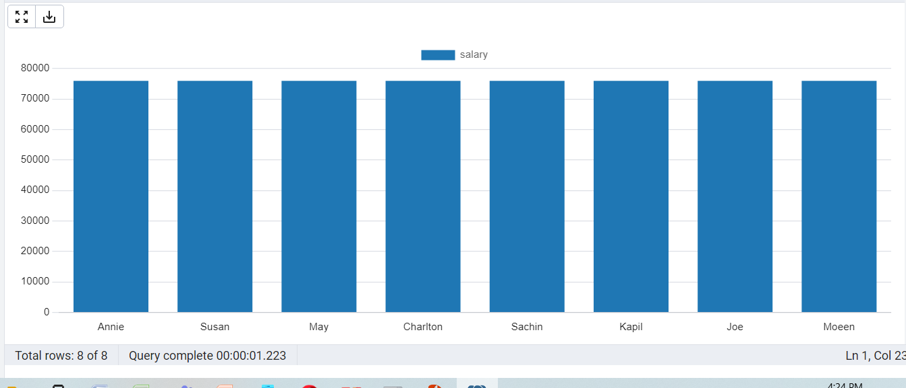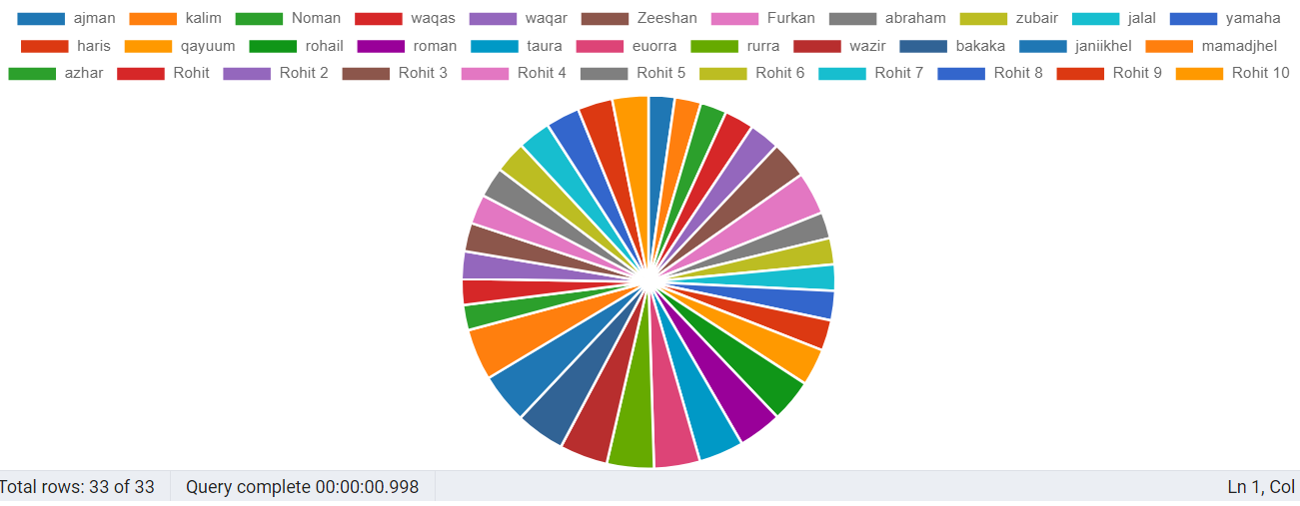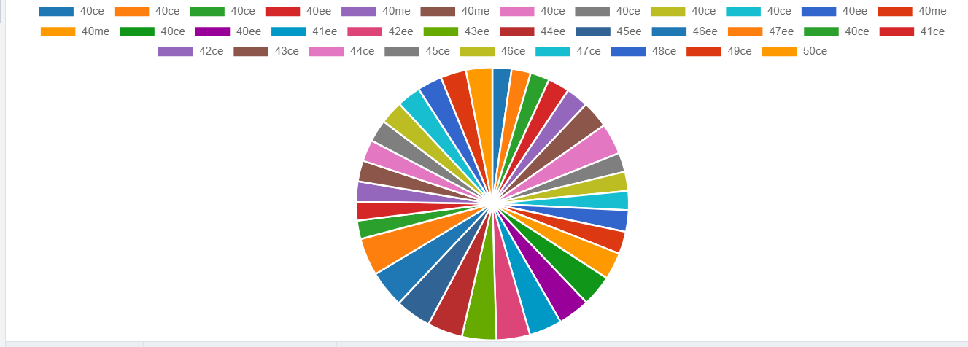

Server [localhost]:

Database [postgres]:

Port [5432]:

Username [postgres]: ajman

Password for user ajman:

psql (15.0)

WARNING: Console code page (437) differs from Windows code page (1252)

8-bit characters might not work correctly. See psql reference

page "Notes for Windows users" for details.

Type "help" for help.

postgres=# \c computereng

You are now connected to database "computereng" as user "ajman".

computereng=# \dt

List of relations

Schema | Name | Type | Owner

--------+---------+-------+-------

public | graphic | table | ajman

(1 row)

computereng=# \du

List of roles

Role name | Attributes | Member of

-----------+----------------------------------------------------------------+------------

ajman | Superuser, No inheritance, Create role, Create DB, Replication+| {postgres}

| Password valid until 2034-11-03 11:57:00+05 |

postgres | Superuser, Create role, Create DB, Replication, Bypass RLS | {}

computereng=# \df

List of functions

Schema | Name | Result data type | Argument data types | Type

--------+------+------------------+---------------------+------

(0 rows)

computereng=# \dv

Did not find any relations.

computereng=# \d graphic

Table "public.graphic"

Column | Type | Collation | Nullable | Default

-----------+-----------------------+-----------+----------+--------------------------------

id | integer | | not null |

firstname | character varying(50) | | not null | 'emp'::character varying

lastname | character varying(50) | | not null | 'khan'::character varying

batch | character varying(50) | | | '40'::character varying

age | integer | | | 20

contact | integer | | | 4118288

city | character varying(50) | | | 'islamabad'::character varying

country | character varying(50) | | | 'pakistan'::character varying

Indexes:

"graphic_pkey" PRIMARY KEY, btree (id)

"firstunique" UNIQUE CONSTRAINT, btree (firstname)

computereng=# insert into graphic values(1,'ajman','khan','40ce',24,4118288,'islamabad','pakistan');

INSERT 0 1

computereng=# insert into graphic values('kalim','khan','40ce',24,4118288,'islamabad','pakistan');

ERROR: invalid input syntax for type integer: "kalim"

LINE 1: insert into graphic values('kalim','khan','40ce',24,4118288,...

^

computereng=# insert into graphic values(2,'kalim','khan','40ce',24,4118288,'islamabad','pakistan');

INSERT 0 1

computereng=# insert into graphic values(3,'Noman','khan','40ce',24,4118288,'islamabad','pakistan');

INSERT 0 1

computereng=# insert into graphic values(4,'waqas','ahmad','40ee',27,4118288,'islamabad','pakistan');

INSERT 0 1

computereng=# insert into graphic values(5,'waqar','ahmad','40me',28,4118288,'islamabad','pakistan');

INSERT 0 1

computereng=# insert into graphic values(6,'Zeeshan','ahmad','40me',34,4118288,'islamabad','pakistan');

INSERT 0 1

computereng=# insert into graphic values(7,'Furkan','ahmad','40ce',39,4118288,'islamabad','pakistan');

INSERT 0 1

computereng=# select * from graphic;

id | firstname | lastname | batch | age | contact | city | country

----+-----------+----------+--------+-----+----------+-----------+----------

1 | ajman | khan | 40ce | 24 | 4118288 | islamabad | pakistan

2 | kalim | khan | 40ce | 24 | 4118288 | islamabad | pakistan

3 | Noman | khan | 40ce | 24 | 4118288 | islamabad | pakistan

4 | waqas | ahmad | 40ee | 27 | 4118288 | islamabad | pakistan

5 | waqar | ahmad | 40me | 28 | 4118288 | islamabad | pakistan

6 | Zeeshan | ahmad | 40me | 34 | 4118288 | islamabad | pakistan

7 | Furkan | ahmad | 40ce | 39 | 4118288 | islamabad | pakistan

8 | abraham | khan | 40ce | 24 | 4118288 | islamabad | pakistan

9 | zubair | khan | 40ce | 24 | 4118288 | islamabad | pakistan

10 | jalal | khan | 40ce | 24 | 4118288 | islamabad | pakistan

11 | yamaha | ahmad | 40ee | 27 | 4118288 | islamabad | pakistan

12 | haris | ahmad | 40me | 28 | 4118288 | islamabad | pakistan

13 | qayuum | ahmad | 40me | 34 | 4118288 | islamabad | pakistan

14 | rohail | ahmad | 40ce | 39 | 4118288 | islamabad | pakistan

15 | roman | khan | 40ee | 40 | 4118289 | lahore | pakistan

16 | taura | khan | 41ee | 41 | 4118290 | lahore | pakistan

17 | euorra | khan | 42ee | 42 | 4118291 | lahore | pakistan

18 | rurra | khan | 43ee | 43 | 4118292 | lahore | pakistan

19 | wazir | khan | 44ee | 44 | 4118293 | lahore | pakistan

20 | bakaka | khan | 45ee | 45 | 4118294 | lahore | pakistan

21 | janiikhel | khan | 46ee | 46 | 4118295 | lahore | pakistan

22 | mamadjhel | khan | 47ee | 47 | 4118296 | lahore | pakistan

23 | azhar | khan | 40ce | 23 | 456783 | bannu | pakistan

24 | Rohit | khan | 41ce | 24 | 456784 | bannu | pakistan

25 | Rohit 2 | khan | 42ce | 25 | 456785 | bannu | pakistan

26 | Rohit 3 | khan | 43ce | 26 | 456786 | bannu | pakistan

27 | Rohit 4 | khan | 44ce | 27 | 456787 | bannu | pakistan

28 | Rohit 5 | khan | 45ce | 28 | 456788 | bannu | pakistan

29 | Rohit 6 | khan | 46ce | 29 | 456789 | bannu | pakistan

30 | Rohit 7 | khan | 47ce | 30 | 456790 | bannu | pakistan

31 | Rohit 8 | khan | 48ce | 31 | 456791 | bannu | pakistan

32 | Rohit 9 | khan | 49ce | 32 | 456792 | bannu | pakistan

33 | Rohit 10 | khan | 50ce | 33 | 456793 | bannu | pakistan

(33 rows)

computereng=# \s

history is not supported by this installation

computereng=#